# Create And Manage Microsoft Teams teams Using PowerShell

## Accessing PowerShell

* In the Windows Search bar type PowerShell
* Select PowerShell or PowerShell ISE but ensure you Run as administrator
* The PowerShell window will open

**Note:** PowerShell ISE is a newer graphical interface that allows multiple tabs to be used as well as a lot of improved functionality.

The commands below work in both PowerShell and PowerShell ISE

## Connecting To Teams

To locate the Teams module and logon successfully we need to execute the following commands

* Install-Module -MicrosoftTeams
* 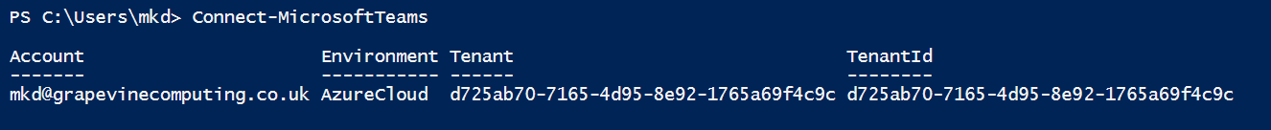Connect-MicrosoftTeams

**Note:** If the 365 login screen prompt appears, log in as usual using two factor authentication if required

## Creating a New Team

To create a new Team with a description and to determine whether it is either public or private type the following

* New-Team -DisplayName “Name of the team” -Description “Description of the Team”  
  -Visibility Private or Public

**Notes:**

The only mandatory parameter is New-Team then at the prompt type the Team name

Other parameters are available to determine other actions users can undertake.

Private Teams are created as default

Text of two words or more needs to be enclosed in double quotes

## Removing a Team

To remove a Microsoft Team you first need to know the Group ID of the Team. The following commands lists all the teams

* A picture containing text, battery

  Description automatically generatedGet-Team

The Team can now be deleted by typing the following

* Remove-Team -GroupID <group ID>

**Notes:**

You can copy the GroupID using Control C and Control V in PowerShell ISE or Alt Space Edit Copy and the Alt Space Edit and Paste in PowerShell.

You do not get a confirmation line on screen

## Adding A Single User to a Team

To add a user, the group ID of the team must be known as well as the email address of the user. Run Get-Team to obtain the Group ID, then type the following script

* Add-TeamUser -GroupId <group ID> -user <email of user>

**Notes:**

The default membership option is Member

To add a user as an Owner rather than a member add -Role Owner to the end of the script

You do not get a confirmation line on screen

Users can be added in bulk using a different script